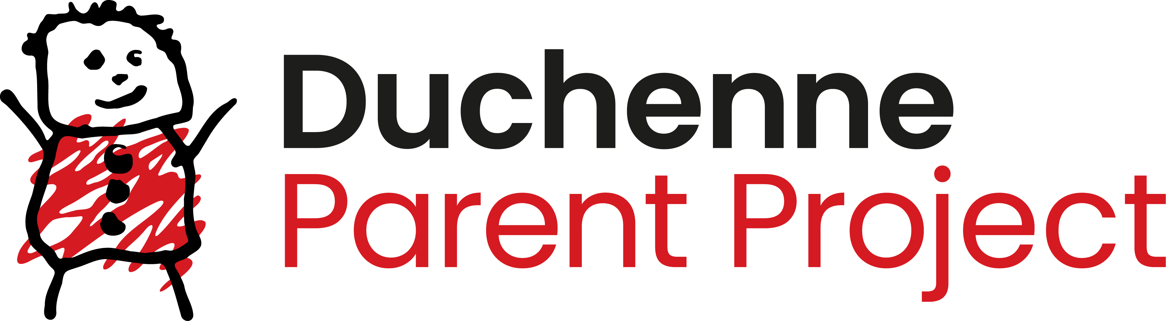 Application form
Duchenne Parent Project NL

2026 Research Call: Adult life with Duchenne
Email to research@duchenne.nl

(Please delete italicized text before submitting the application. The total grant application should not exceed 20 pages and should be written in font size 11.)

- Project title:

- Applicants

Name main applicant:
Principal investigator of research group:
University/Institute:
Faculty/Hospital:
Department:
Address:
E-mail:

If applicable, name co-applicant:
Principal investigator of research group:
University/Institute:
Faculty/Hospital:
Department:
Address:
E-mail:

(please add more if needed)

- Project
Total amount requested (in euro):
Proposed starting date:
Duration:

- Abstract of the project
Please add a scientific abstract of max. 250 words.

- Summary for the general public
Provide a short summary which we can publish on our website if your project is accepted for funding. This should also contain a graphic element. There is no need to explain DMD. The summary can be written in English or Dutch language (max. 350 words).

- Problem and causes
Please describe the specific problem for adult people with Duchenne that you want to address with your project. What are the causes of the problem? What are the knowledge gaps?

- Intended impact
Explain as concrete as possible the intended long-term impact for adult people with Duchenne where you want to contribute to with your project (What kind of change in e.g., well-being, (psychosocio-)care or therapy could this research lead to?). This impact should be formulated at the same level as the identified problem and should clearly relate to the proposed research.

- Impact pathway
Which changes and actions by public and private parties are needed to achieve the intended impact. Describe these changes and actions as concrete as possible: who should do what (differently) in order to reach the intended impact
Describe the knowledge and insights that are needed by the described public and private parties.

- Project description
Starting with the identified knowledge gaps and the required knowledge/insights, describe the scientific objectives of your project. Please describe the background for the project, the state-of-the-art, the hypotheses and the specific aims.

- Intended project results
Please describe the intended results from the project.

- Previous work
How does this project build on previous grants/projects, how does it relate to other research initiatives in the relevant research area?

- Relevance to the theme of the call
Indicate why the topic of your research is of specific important for adults living with
Duchenne.

- CV
Please provide a biosketch of the main applicants (max. 250 words) and up to 5 publications. Mark publications relevant to this application with an *

- Previous grant applications
Please provide an overview of other support for the applicants (active grant applications granted or under review) with explicit reference to aims that might show overlap with research in this proposal.

- References
List of references, max 30.

- Signatures
By signing this application form I agree with the grant conditions as stated on the website https://duchenne.nl/research-application/

Applicant Legal representative

Date: Date:
Name: Name:
Signature: Signature:

